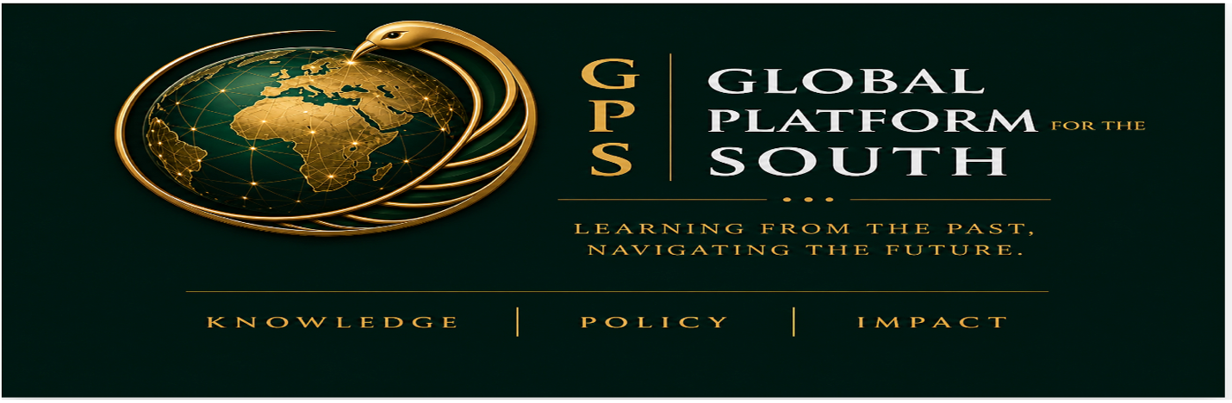

Global Platform for the South (GPS)

- FOUNDATIONS

- Context & Rationale
*GPS is a transdisciplinary research and policy ecosystem and platform
The Global Platform for the South (GPS) is a transdisciplinary research ecosystem, policy platform, and convening institution dedicated to advancing applied knowledge and innovation for social transformation across the Global South. Rooted in the South and globally connected, the GPS brings together universities, governments, communities, civil society actors, strategic partners, entrepreneurs, and artists to co-design and implement context-responsive solutions to shared challenges.
The GPS aims at connecting and mobilizing the abundant sources of oral knowledge, indigenous experience, and inherent creative and scientific innovation that lack visibility and lay in inertia across Africa, Latin America and the Caribbean, Asia and the Middle East, and their diasporas.
The GPS intends to connect and mobilize the abundant sources of oral knowledge, indigenous experience, and inherent creative and scientific innovation that lay in inertia across Africa, Latin America and the Caribbean, Asia and the Middle East, and their diasporas, waiting for visibility.
This dynamic aims to ensure the full translation and localization of our innovative ideas into concrete policies, actionable solutions, and measurable impact.
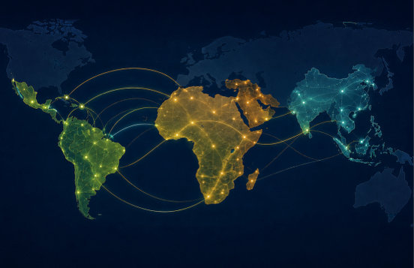
This Southern reality unfolds within a rich history of vision and collective action from the Bandung Conference to the Lagos Plan of Action, the Abuja Treaty, the ASEAN Community Vision, Arab regional frameworks, the Buenos Aires Plan of Action, CELAC initiatives, CARICOM integration efforts, and the United Nations Sustainable Development Goals. The Global South has consistently advanced ambitious foundational frameworks for sovereignty, regional integration, cooperation, and long-term development.
However, a gap persists between vision and implementation, and numerous structural constraints shape this dynamic across several Southern state contexts. They include:
- fragmentation across sectors such as governance, economy, technology, environment, and education
- limited alignment between knowledge production and public policy
- under-integration of local, indigenous, and experiential knowledge systems
- challenges to scaling research and innovation into sustainable, system-wide impact
- misaligned incentive systems across academia, policy, and funding environments
Meanwhile, deeply interconnected systemic challenges interface an increasingly complex landscape shaped by climate change, inequality, digital transformation, and geopolitical shifts, and conflicts in the Global South..
They compartmentalize knowledge production within specialized or isolated domains without sustained dialogue across sectors or everyday realities. Several other interrelated factors, the enduring influence of colonial legacies and forms of epistemic eurocentrism continue to shape research agendas, academic hierarchies, and the valuation of knowledge systems, limiting the integration of locally grounded perspectives to regional priorities.
Public policy processes also do not draw on the full range of home expertise, and closely tie decision-making to externally driven technical assistance frameworks and sources of development financing—which constrain the space for locally produced knowledge and policy.
Consequently, the academic landscape faces internal tensions, research trajectories orient critique for lacking pathways to application, or they align with dominant global paradigms displaying insufficient contextual adaptation. These tendencies weaken the translation of local knowledge into scalable impact.
Many contexts show underdeveloped institutional interfaces between research and policy—creating a “missing middle” that limits the systematic translation of knowledge into decision-making.
A knowledge ecosystem, by contrast, requires structured collaboration across disciplines, regions, and sectors—especially with policymakers—aiming to better inform public decisions in such areas as public health, education, and environmental policy. GPS rebuilds these connections—linking knowledge, policy, and practice across different fields and contexts, and helps in moving ideas from research into real-world solutions. It bridges this “missing middle” by creating pathways between ideas and implementation. It calls for equitable partnerships, aligning locally grounded research to priorities defined by the Global South states.
These realities do not simply require new plans, but a renewed approach for framing, connecting, mobilizing, and translating Southern knowledge into action research. At its core, GPS recognizes the link between sustainable development and the continuous circulation and application of knowledge across institutions, communities, and decision-making spaces—linking ideas to policy, and policy to action.
Thus, GPS emerges as a next-generation platform placing academic, local, indigenous, and experiential knowledge at the center, and organising action across interconnected domains—methodology, epistemology, culture, socio-economic systems, technology, and environment. GPS enables a living ecosystem and integrated functions across sectors that have long operated in isolation.
GPS’ core framework—Knowledge → Policy → Impact (KPI)— serves as a diagnostic platform for identifying and understanding key challenges and gaps. It functions as a policy interface, connects knowledge to decision-making processes, and informing policy design. It also acts as an implementation bridge by supporting the translation of ideas and policies into concrete action and measurable impact.
Headquartered in Kigali, with regional hubs across the Global South and partnerships in the Global North, GPS functions as a platform of plural knowledge systems where institutions and communities, civil society actors, strategic partners, entrepreneurs, artists and governments work together to generate scalable, context-responsive solutions.
- About GPS
The name Global Platform for the South (GPS) focuses on identity and function, as “form follows function” (Louis Sullivan). It reflects both identity and functional agency as:
- Global: interconnecting solution research to challenges across regions, disciplines, and systems
- Platform: enabling coordination, collaboration, and collective action
- South: fostering a space sharing history, experience, creativity, and knowledge—including its diasporas
Like a navigation system, GPS helps actors:
- locate themselves within evolving global knowledge systems
- align priorities across institutions and regions
- chart pathways toward shared futures
In honoring the spirit of navigation, GPS also recognizes Gladys West, whose pioneering work contributed to modern satellite positioning—reminding us that transformative knowledge often emerges from communities and places that are too often overlooked.
At its core, GPS is a living platform powered by people, institutions, and ideas in motion. Inspired by the Sankofa principle, GPS affirms that the future is shaped by drawing on the wisdom of the past in the present actions. Sankofa and GPS connect traditions—indigenous and endogenous knowledge systems, lived experiences, and local realities—with emerging technologies and global perspectives.
GPS is simultaneously:
- a hub of research and knowledge institutions
- a policy implementation platform
- a leadership and training ecosystem
- an innovating and accelerating partnership pivot
- a global convening forum for dialogue
- a strategic catalyst for Global South transformation
Together, these dimensions position GPS not merely as a forum for dialogue, but as an integrated ecosystem designed to connect knowledge, policy, innovation, and action in ways that generate measurable and sustainable impact.
- Vision
GPS envisions a future where the intellectual, cultural, scientific, creative, and entrepreneurial forces of the Global South are deeply connected to the socio-economic challenges and aspirations of their societies, and where collaboration across disciplines, sectors, cultures, and knowledge systems contributes to a more sustainable and inclusive world.
- Mission
GPS advances socially grounded and evidence-based transformation by integrating scientific research, indigenous knowledge systems, innovation ecosystems, artistic practice, economic development, and policy design. Its mission is to connect science and policy, communities and institutions, and research and action in order to foster informed decision-making, inclusive collaboration, and measurable societal impact across the Global South and beyond.
- Knowledge-Policy-Impact (KPI) Framework
GPS is structured around a simple but powerful principle and operating philosophy:
The operating philosophy of GPS is structured around a simple but powerful principle. It starts from real-world situations, contextual realities, and lived, observed and carefully analysed experiences that generate knowledge and inform policy formulation and implementation processes. In turn, the form of policy follows function in tangible ways, leading to real-world impact. This framework ensures that ideas do not remain theoretical—but are translated into action and quantifiable change.
In turn, the framework of policy functions in tangible ways, leading to real-world impact and translating theoretical ideas into action and quantifiable change.
- OBJECTIVES
- Integrate Research, Education, and Policy
Translate knowledge into actionable strategies that inform decision-making and strengthen institutions.
- Cultivate Knowledge Rooted in Lived Realities
Connect Indigenous, and Creative Knowledge systems of the Global South with Northern scholarship on equitable terms.
- Advance Sustainable Development and Innovation
Especially support initiatives in food/agriculture, education, health, climate, technology, and entrepreneurship.
- Facilitate Learning Mobility and Cooperation
Strengthen South–South and South–North collaboration through academic and professional exchange.
- Strengthen Research-to-Impact Ecosystems
Enable institutions to transform ideas into policies, actionable ventures, and scalable solutions.

- OPERATIONAL ECOSYSTEM
- Operational Model
GPS functions as an integrated ecosystem connecting education, research, policy, training, and innovation.

- Initial hubs:

- Kigali (Headquarters)
- Addis Ababa (Est Africa)
- Dakar (West Africa)
- São Paulo (Latine America)
- Martinique (The Caribbean)
- Middle East (TBA)
- Asia (TBA)

- Core activities:
This model ensures continuous movement from knowledge → policy → impact.

High-Impact Flagship Programs

- Research fellowship
- Executive training
- Policy advisory
- Innovation lab
- Academic mobility
- Cultural initiative
- Strategic convening

- GPS CORE DOMAINS

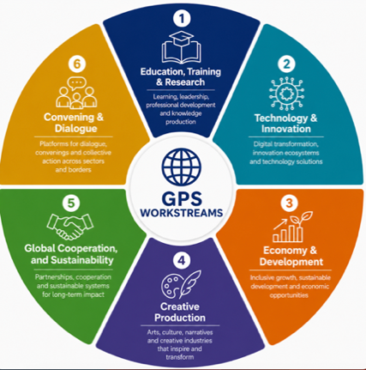

GPS operates through a set of interconnected domains that generate knowledge, build capacity, drive implementation and innovation, convene actors, and mobilise partnerships and resources across the Global South.

1. Education, Training & Research
Strengthening leadership formation, professional development, learning systems, and knowledge production across the Global South and globe.

Key Areas
- Knowledge production and research (General)
- Policy-oriented research
- Executive and professional training
- Diplomatic and policy training
- Leadership development programs
- Youth and emerging leader programs
- Capacity building and certification programs
- Interdisciplinary and transdisciplinary initiatives
- Higher education partnerships
- Curriculum development
- Student and faculty collaboration
- Academic mobility and exchange
- Knowledge-sharing platforms
- Publications and dissemination

2. Technology & Innovation
Advancing technological solutions, digital transformations, and innovation ecosystems to address local and global challenges.

Key Areas
- Artificial intelligence and digital transformation
- Innovation labs and incubators
- Data systems and analytics
- Policy dashboards and foresight tools
- Smart and sustainable technologies
- Emerging technologies
- Education, health, and governance technologies
- Innovation partnerships
- Digital entrepreneurship
- Research commercialization

3. Economy & Society
Promoting inclusive growth, sustainable development, and transformative economic opportunities rooted in local realities of the Global South.

Key Areas
- Sustainable development initiatives
- Community-centered development
- Youth employment and empowerment
- Entrepreneurship and startups
- Social and solidarity economies
- Economic policies and development strategies
- Climate resilience and green economies
- Trade and regional integration
- Agriculture and food systems
- Infrastructure and urban transformation

4. Creative Production
Encouraging artistic, literary, creative, and cultural expressions for preserving memory, shaping narratives, and imagining new futures.

Key Areas
- Literature and creative writing
- Arts and cultural production
- Film, media, and storytelling
- Music, performance, and visual arts
- Creative industries
- Digital Publics
- Humanities and cultural engagement
- Indigenous and local narratives
- Historical memory and archives
- Cultural diplomacy
- Publishing initiatives

5. Global Cooperation, Finance & Sustainability
Building strategic partnerships, sustainable financing models, and international cooperation frameworks to support long-term impact.

Key Areas
- International partnerships and diplomacy
- South–South and South–North cooperation
- Philanthropy and donor engagement
- Long-term sustainability strategies
- Resource mobilization
- Public-private partnerships
- Strategic investment partnerships
- Development finance
- Institutional sustainability
- Governance and organisational strengthening

6. Convening & Dialogue
Creating spaces where policies, ideas, research, innovation, and partnerships converge to generate collective action and measurable impact.

Key Areas
- International conferences and summits
- Kigali Knowledge Crossroads Week
- Global South dialogue platforms
- Policy forums and roundtables
- Academic and professional convenings
- Leadership dialogues
- Cross-sector collaboration spaces
- Public engagement initiatives
- Cultural and intellectual exchanges
- Strategic global conversations

Examples
- Kigali Flagship Convening (2027)
- São Paulo Convening (2028)
- Governance & Organizational Structure

1. Board of Directors
The GPS Board of Directors provide institutional oversight, governance, fiduciary responsibility, and long-term strategic direction.

2. International Advisory Board (IAB)
The IAB provides strategic global guidance, strengthens institutional credibility and international visibility, supports partnerships and resource mobilization, and helps position GPS within global and Global South ecosystems of knowledge, policy, innovation, and development.
It comprises a distinguished and internationally recognized body of university leaders, current and former policymakers, ministers, diplomats, private sector leaders, donor representatives, and leading scholars and experts, reflecting the diversity, priorities, and aspirations of the Global South and its partners worldwide. The Board serves as a platform for bridge-building across academia, policy, diplomacy, philanthropy, business, and innovation ecosystems, advancing GPS’s mission of translating knowledge into policy, partnerships, and measurable impact.

2.1. Leaders and Representatives of Key Institutions and Sectors
The International Advisory Board brings together distinguished leaders from government, academia, business, diplomacy, and international organizations across the Global South and beyond.

2.2. Former Ministers, Diplomats, and Public Leaders
- José Brito
Former Minister of Foreign Affairs and former Minister of Economy of Cabo Verde; former Ambassador to the United States, Canada, and Mexico; and currently Co-Founder and Managing Partner of IHABA, a business development and advisory firm.
He has also contributed to the Africa Innovation Summit and played an important role in advancing Cabo Verde’s renewable energy strategy.
- Natalie Campbell-Rodriques
Jamaican diplomat, policymaker, entrepreneur, and organizational management professional, currently serving as Jamaica’s High Commissioner to Trinidad and Tobago.
Her experience spans diplomacy, public policy, international development, entrepreneurship, and South–South cooperation. She previously served as a Senator in Jamaica, Advisor to the Ministry of Foreign Affairs and Foreign Trade, and Founder and Managing Director of a business operating in Rwanda.
- Haile Gebrselassie (under discussion via Paulo Pan)
Olympic champion and globally renowned long-distance runner, now a prominent entrepreneur and investor in hospitality, real estate, and energy sectors.
- Former President Sahle-Work Zewde (contact under discussion via Hirut)
Former President of Ethiopia and experienced diplomat with extensive leadership in international relations and multilateral cooperation.

2.3. University and Academic Leadership (Regional and Global Associations)
- Prof. Margee Ensign
University president, scholar, and internationally recognized leader in higher education, governance, ethics, and global engagement.
- Prof. Kenneth Kamwi Matengu
President, Association of African Universities (AAU)
Vice-Chancellor, University of Namibia (UNAM), Windhoek, Namibia
Email: kmatengu@unam.na
- Prof. Jorge Calzoni
President, Unión de Universidades de América Latina y el Caribe (UDUALC)
Rector, Universidad Nacional de Avellaneda (UNDAV), Buenos Aires, Argentina
(To be contacted by Hirut)
- Prof. Hari Mohan Gupta
President, Association of Universities of Asia and the Pacific (AUAP)
Chancellor, Jagran Lakecity University, Bhopal, India
(To be contacted by Wajiya)
- Prof. Amr Ezzat Salama
Secretary General, Association of Arab Universities (AArU)
Former Minister of Higher Education and Scientific Research, Egypt
Headquarters: Amman, Jordan
(To be contacted by Hirut)
- Prof. Ahmed Al Raeesi
President, Asian Universities Alliance (AUA)
Acting Vice-Chancellor, United Arab Emirates University (UAEU), Al Ain, United Arab Emirates
(To be contacted by Hirut)
- Prof. Rossana Valéria de Souza e Silva
President, Grupo de Cooperação Internacional de Universidades Brasileiras (GCUB)
Rector, Universidade Federal Rural de Pernambuco (UFRPE), Brazil
(To be contacted by JP)
- Caribbean University Networks (TBC)
Representative / President – Universities Caribbean / Association of Caribbean Universities (UC/ACU)
(Cf. Myriam)
- Caribbean University Consortium (TBC)
Representative / President – Consortium of Caribbean Universities (CCU)
(Cf. Myriam)

Additional Strategic Members (Pipeline)
Additional members may include former heads of state, ministers, ambassadors, leaders of international organizations, prominent entrepreneurs, philanthropists, and distinguished intellectuals from the Global South and beyond, to further strengthen the diversity, legitimacy, and global reach of the Advisory Board.

3.Operational Team
The Operational Team oversees the day-to-day management, institutional operations, program implementation, partnerships, communications, and organizational sustainability of GPS.

4.Division Chiefs
The Division Chiefs oversees the six core domains of GPS and ensures strategic alignment, cross-domain collaboration, and coherence across programs, research, partnerships, and institutional priorities.
Division Chiefs / Core Domains
- Education, Training & Research
- Technology & Innovation
- Economy & Development
- Creative Production & Cultural Industries
- Global Cooperation & Sustainability
- Convening, Dialogue & Knowledge Exchange
5.Regional Hubs
The Regional Hubs & Coordination Unit coordinates GPS activities, partnerships, institutional engagement, and ecosystem development across regions.
Each regional hub operates under the leadership of a Regional Coordinator responsible for regional strategy, partnerships, programming, stakeholder relations, and institutional development.
Regional Hubs
- Kigali Headquarters — Rwanda
- Addis Ababa Hub — Ethiopia
- Dakar Hub — Senegal
- São Paulo Hub — Brazil
Additional hubs may be established progressively in Asia, the Middle East, and other regions of the Global South.

